
We hope, through this activity, you will be more interested in learning English, improving your speaking ability, and becoming a person of multiple languages. In the future, these will surely be considered the greatest assets at work. Welcome to Malaysia!
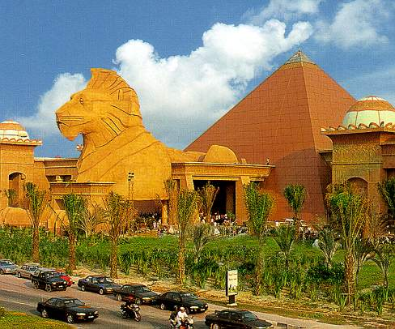


繽紛．物超所值． 東方邂逅西方
2015
吉隆坡臺灣學校2015.7.2 ~ 7.11 (10天)

- 暑期英語研習營招生

Welcome to Malaysia! 優良外語師資 設備 美麗的陽光 古蹟
I hope you have a fantastic time at this holiday camp. Try to have as much fun as you can. Don’t worry about it making mistakes in your English, just try and learn from them. Make new friends, share new experiences, and learn along the way. Set a goal to learn one new thing/ word / phrase everyday. Then share it with your friends; this will help you to remember what you have learnt. Finally play hard, work hard, and sleep well!
◎費用 新台幣28000元 (機票機場稅等自付)
◎簡章 報名表 可上吉隆坡臺灣學校網站www.cts.edu.my下載
○洽詢academic110.cts@gmail.com報名資格：國一至高三同學(64人)

No. 1, Persiaran Sg. Selangor, Bkt. Rimau, 40460. Seksyen 32. Shah Alam, SELANGOR DE, MALAYSIA
歡迎您成為我們的好朋友 即日起報名額滿為止
報名洽詢TEL:+60-3-51213100傳真FAX :+60-3-51213108

